

**AMERICAN INTERNATIONAL UNIVERSITY- BANGLADESH**

**(AIUB)**

**Introduction to Electrical Circuit**

**FALL 2023-2024**

**Section: L, Group: 07**

**LAB REPORT ON**

***Analysis of RLC parallel circuits and verification of KCL in RLC parallel circuit related to AC circuit***

**Supervised By**

**MD. SHAHARIAR PARVEZ**

|  |  |
| --- | --- |
| **Name** | **ID** |
| **1.MD. Abdullah** | **22-48065-2** |
| **2.Azmir Islam Kafi** | **22-47981-2** |
| **3.Mohammad Ansar Uddin** | **22-47975-2** |
| **4.Chinmoy Guha** | **22-48056-2** |
| **5.Suvra Chakraborty** | **22-48067-2** |

***Abstract:***

An RLC circuit (or LCR circuit or CRL circuit or RCL circuit) is an electrical circuit consisting of

a resistor, an inductor, and a capacitor, connected in series or in parallel. The RLC part of the name

is due to those letters being the usual electrical symbols for resistance, inductance and capacitance

respectively. The Parallel RLC Circuit is the exact opposite to the series circuit. The analysis of

parallel RLC circuits can be a little more mathematically difficult than for series RLC circuits. This

time instead of the current being common to the circuit components, the applied voltage is now

common to all so we need to find the individual branch currents through each element. The total

impedance, Z of a parallel RLC circuit is calculated using the current of the circuit similar to that

for a DC parallel circuit, the difference this time is that admittance is used instead of impedance.

The objectives of this experiment are-

• To determine phase relationship between IL and IC in a RLC parallel circuit.

• Draw the complete vector diagram for a RLC parallel circuit.

• Verification of KCL in AC circuits.

***Circuit diagram:***

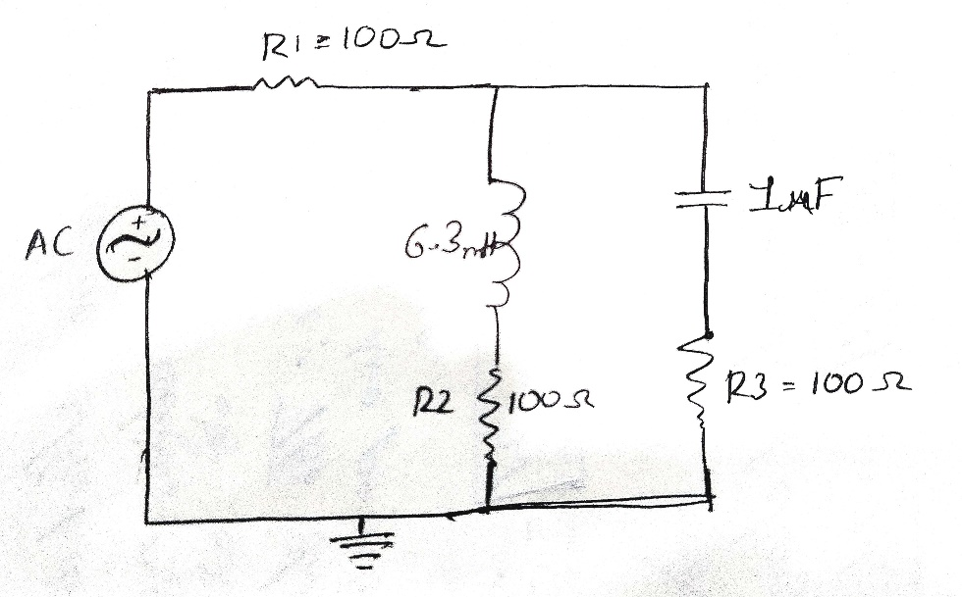

***Figure 1: RLC parallel circuit***

**Apparatus:**

a) Oscilloscope

b) Function generator

c) Resistor: 100 ohm (3)

d) Inductor: 6.3 mH

e) Capacitor: 1microF

f) Connecting wire.

g) Bread board

***Experimental Procedure:***

The circuit shown in Figure 1 was successfully constructed, with channel 1 of the oscilloscope connected across the function generator and channel 2 across RL. We set the amplitude of the input signal to 5V peak, adjusted the frequency to 1 kHz, and selected a sinusoidal wave shape. The values of VRL and IL were measured, and the phase relationship (θL) between E and VRL was determined. Channel 2 of the oscilloscope was then connected across RC, and measurements for VRC and IC were taken. The phase relationship (θC) between E and VRC was determined. Phasors IL and IC were added, and subsequently, channel 2 of the oscilloscope was connected across R to measure VR and IR. The phase relationship (θ) between E and VR was determined. The theoretical sum of IL and IC was compared with the practically obtained value of IR. The same procedures were repeated for input frequencies of 2 kHz and 4 kHz to comprehensively analyze the circuit behavior across different frequency settings.

***Result analysis :***

**Data Table:**

|  |  |  |  |  |  |  |  |  |
| --- | --- | --- | --- | --- | --- | --- | --- | --- |
| f | Vrl | Il  =VRL/RL | 𝜃𝐿 | Vrc | Ic  =VRc/Rc | 𝜃𝑐 | IL+Ic | Vr |
| 1KHz | 87° | 0.02 | 47° | 87° | 0.01 | 99° | 5° | 5° |
| 2KHz | 8° | 0.02 | 62° | 2. 25° | 0.02 | 76° | 0. | 2. |
| 4KHz | 13° | 0.0123 | 435° | 2. 91° | 0.0123 | 435° | 2° | 014° |

***Simulation:  
  
TABLE 1:***

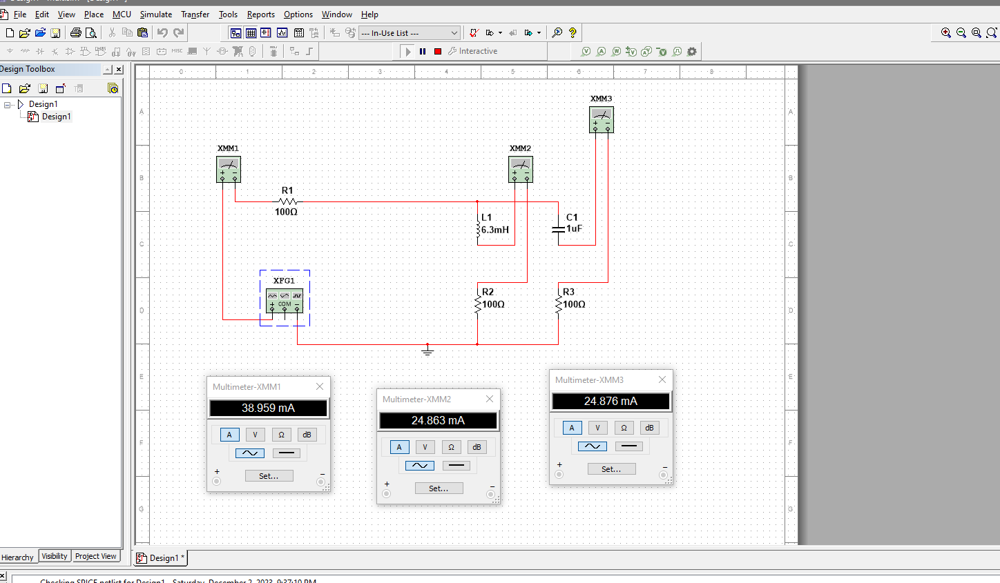

***Figure: Frequency 1kHz***

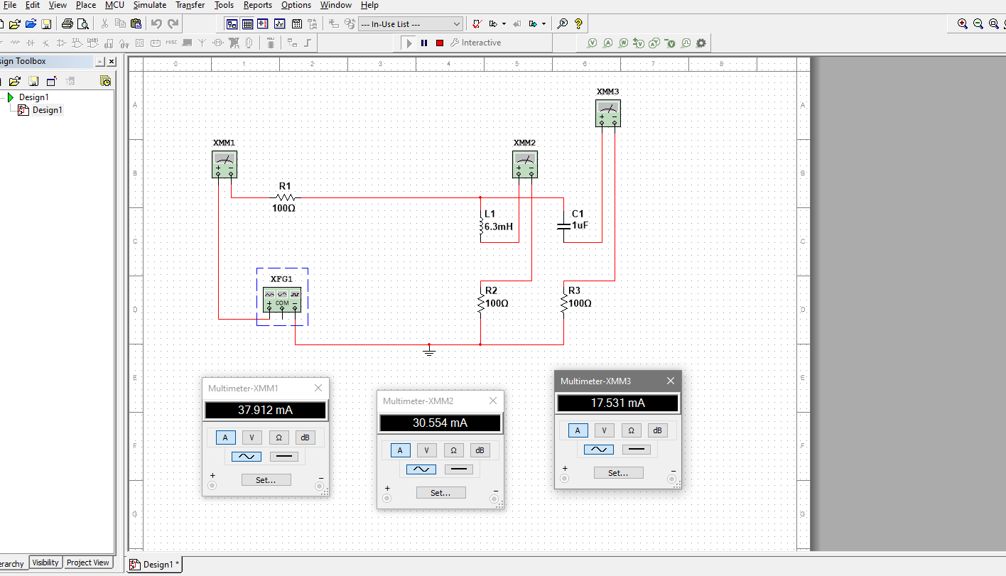

***Figure: Frequency 2kHz***

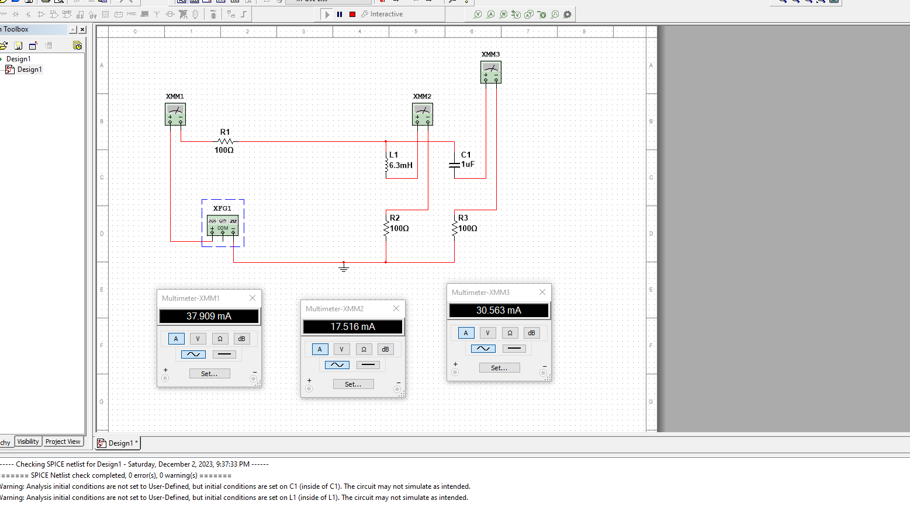

***Figure: Frequency 4kHz***

***Calculation:***

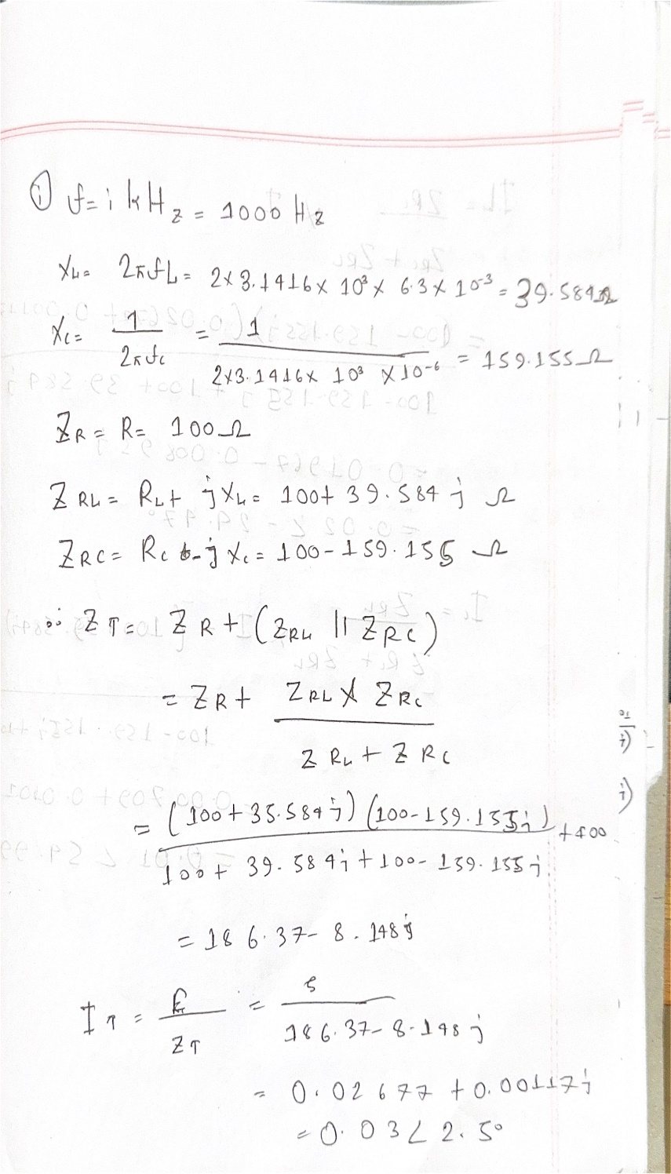

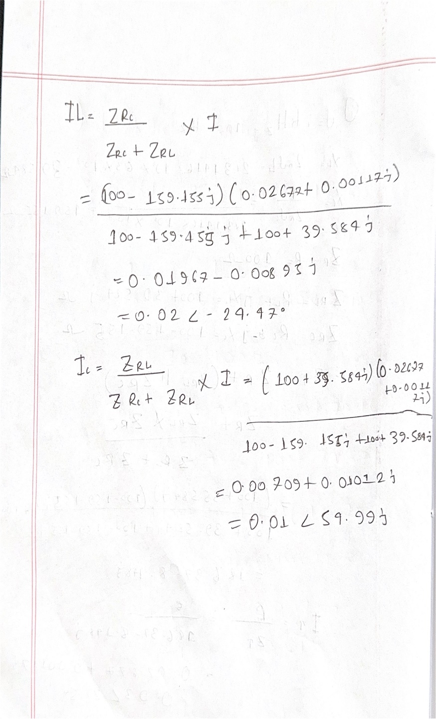

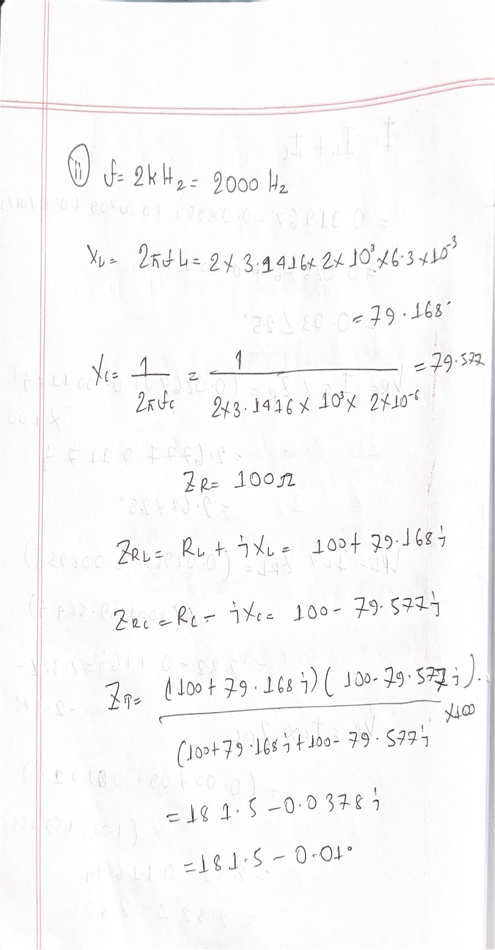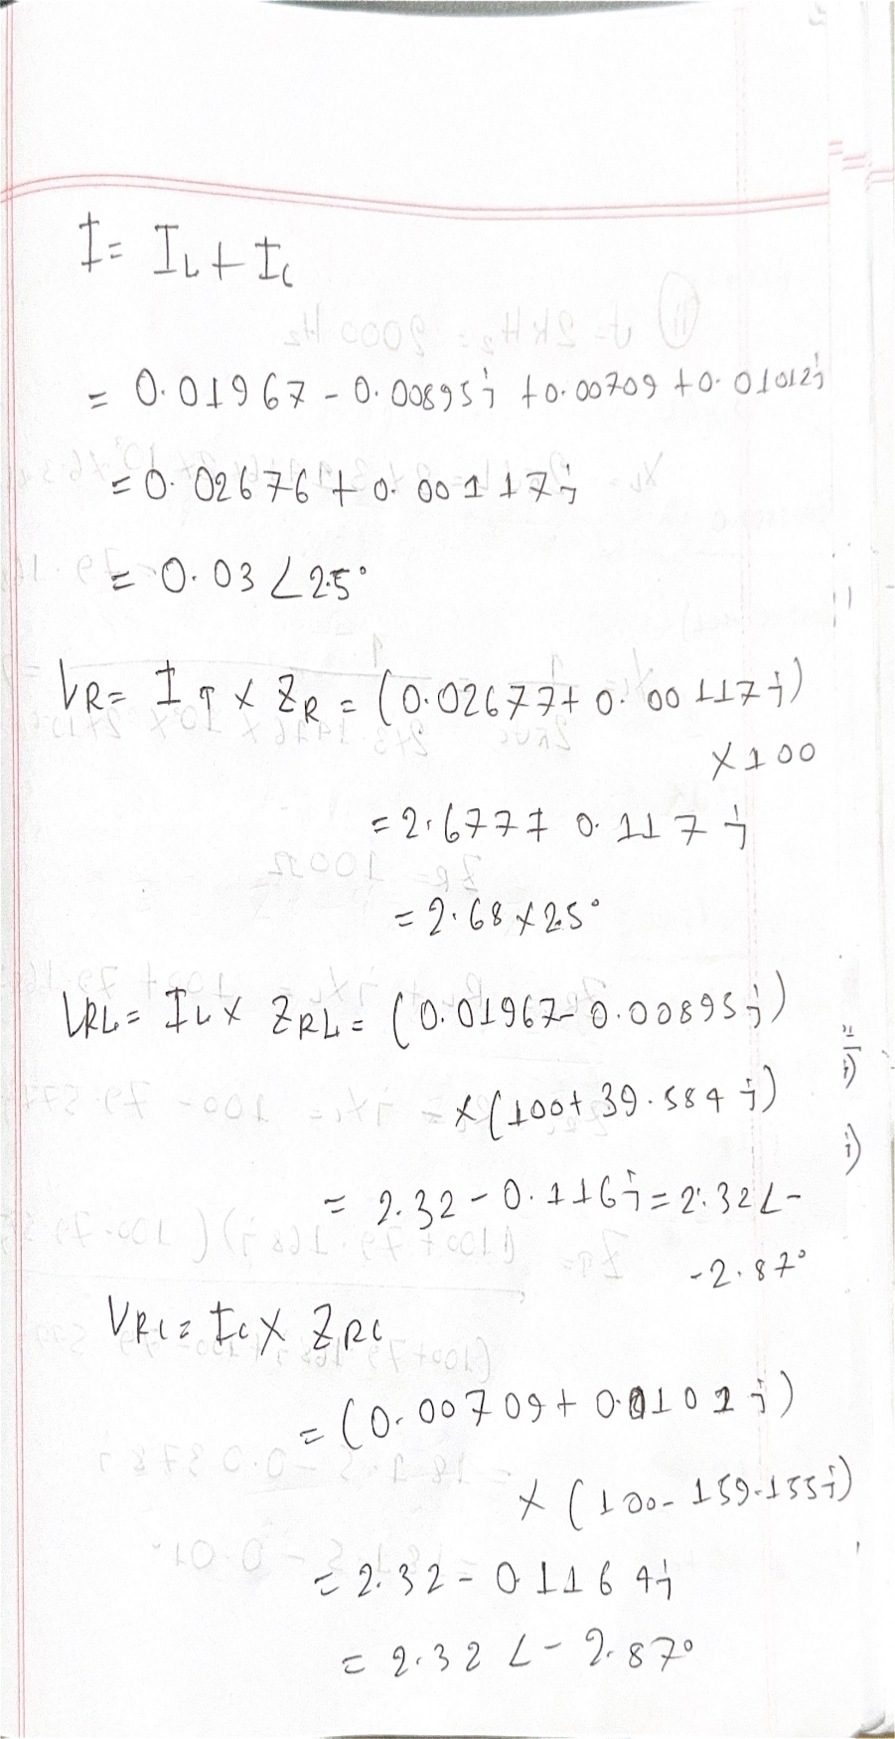

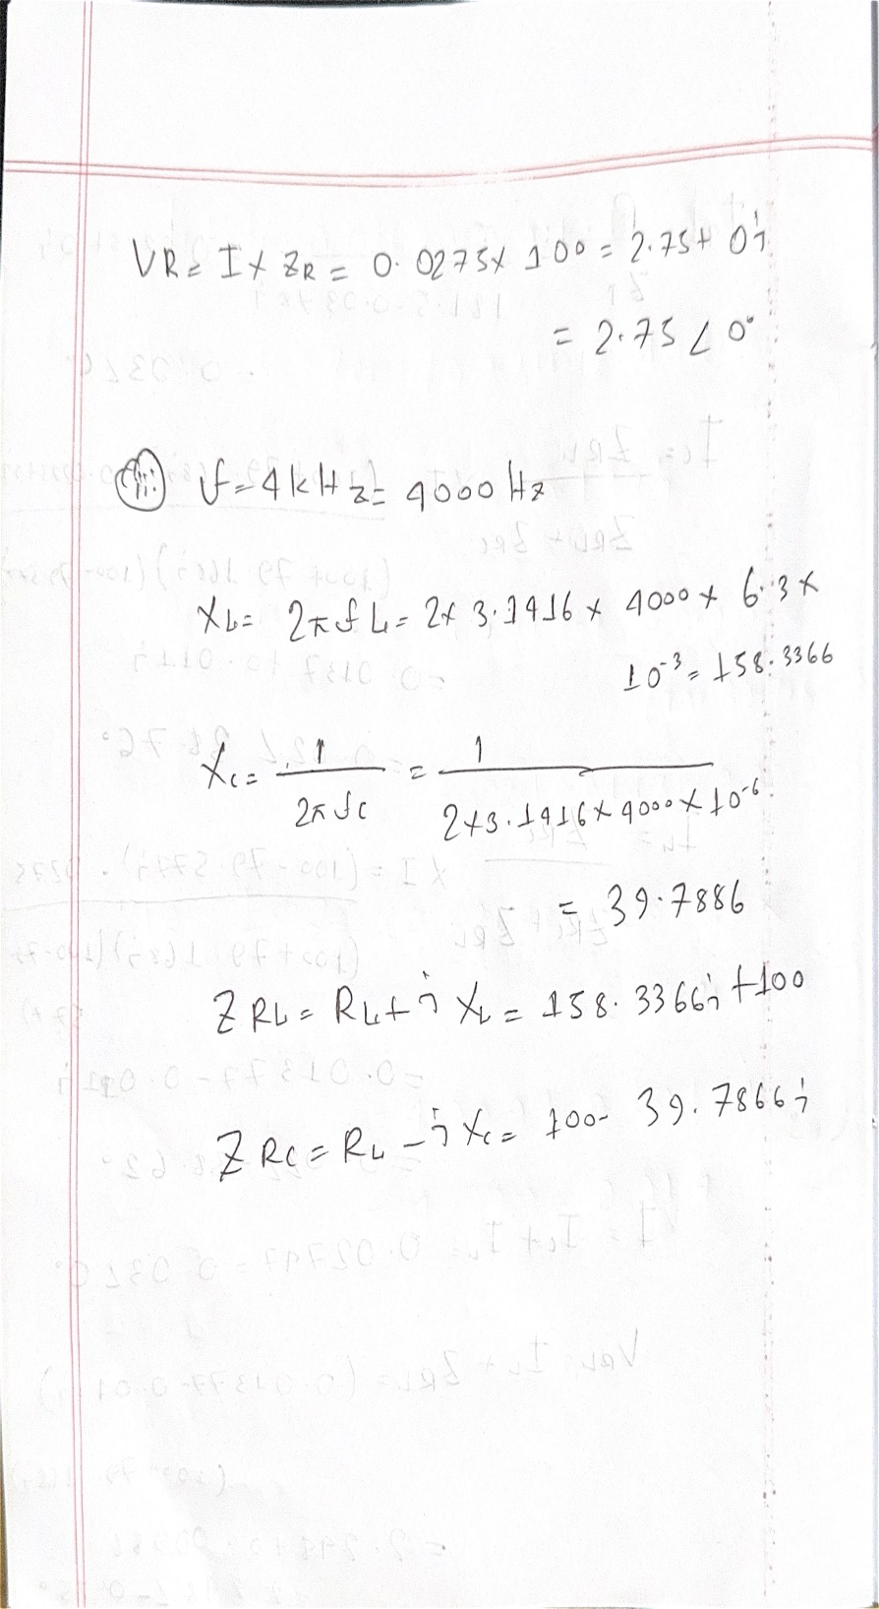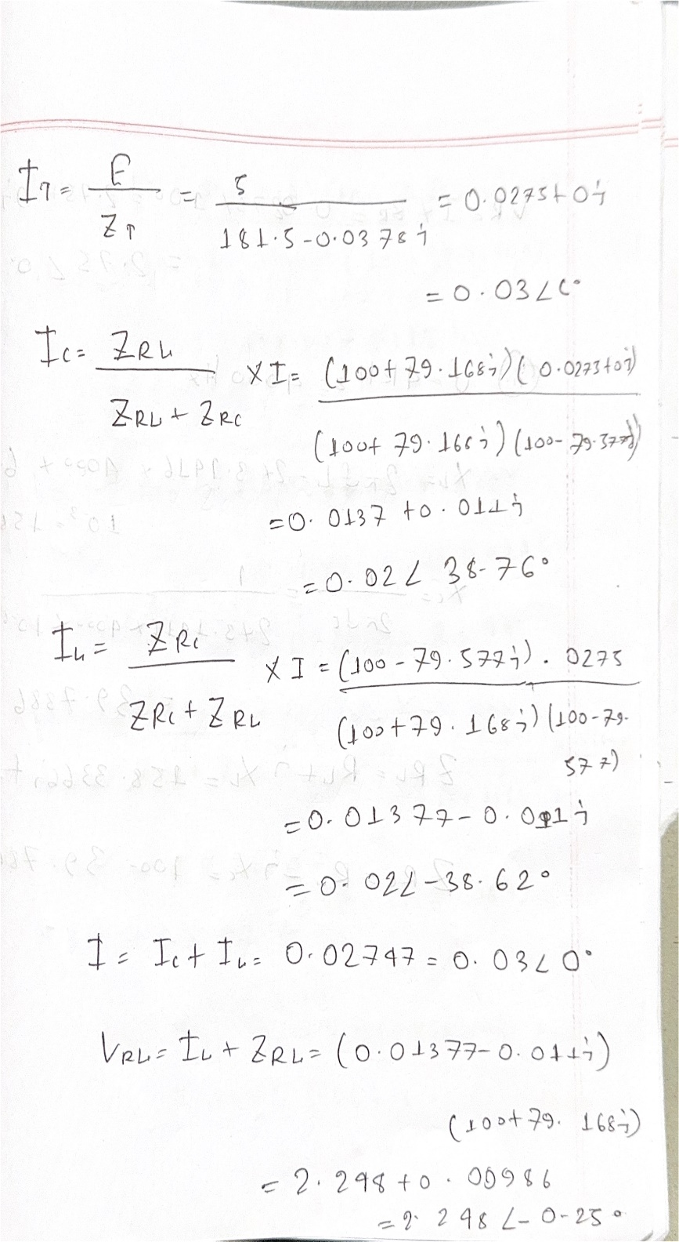

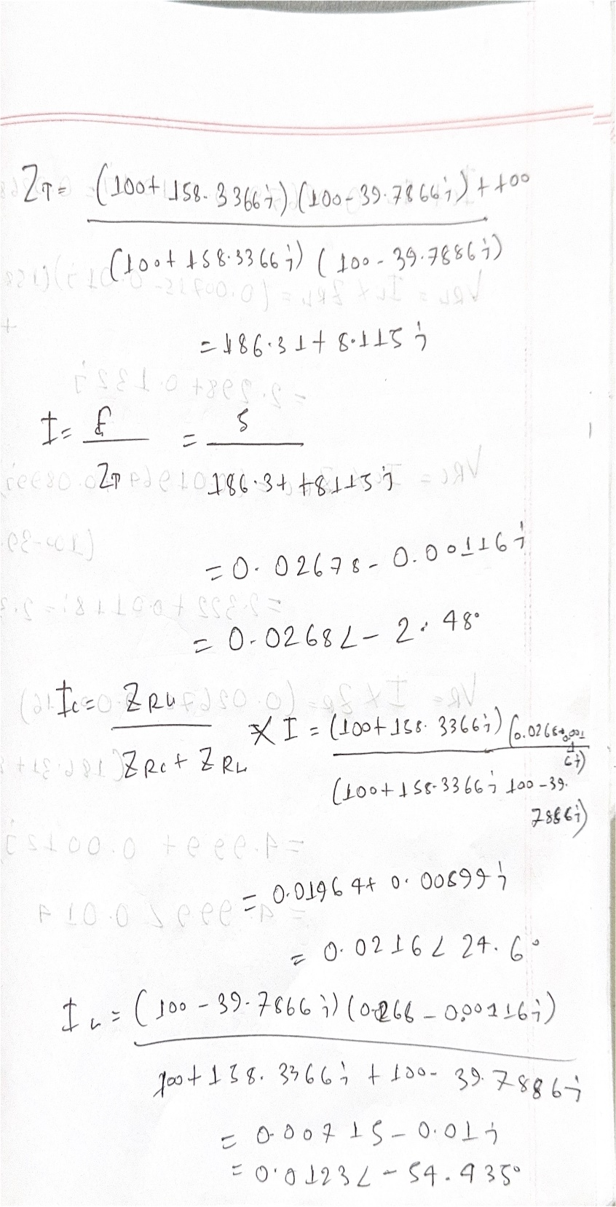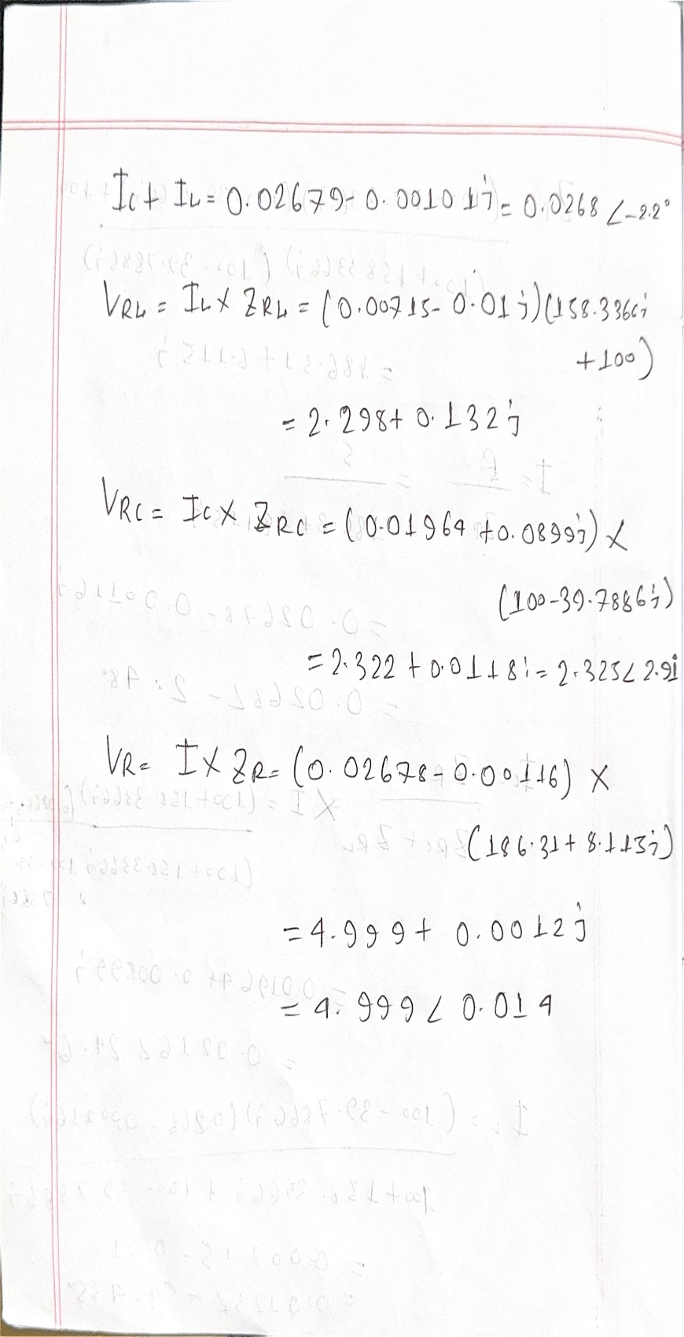

***Discussion***

If we apply KCL,

I = IL + IC

This condition must be true. But there might be some mismatch of the measured value with the

theoretical value because we are taking the value as fraction. If we take all the values from the

fractional part, results must be equal. When we are taking the values from the waveforms,

approximate data are taken so there might be some error too.

In this experiment, we got a value which was very close to our expected value.

***Conclusion:***

By completing this experiment we had become familiar with function generator and oscilloscope. Measuring RLC parallel circuits and we verified KCL in RLC series circuit.